XIII All-Russia scientific conference with international engagement
«Integrated studies of SPITSBERGEN nature and offshore»
(2-4 November 2016, Murmansk)
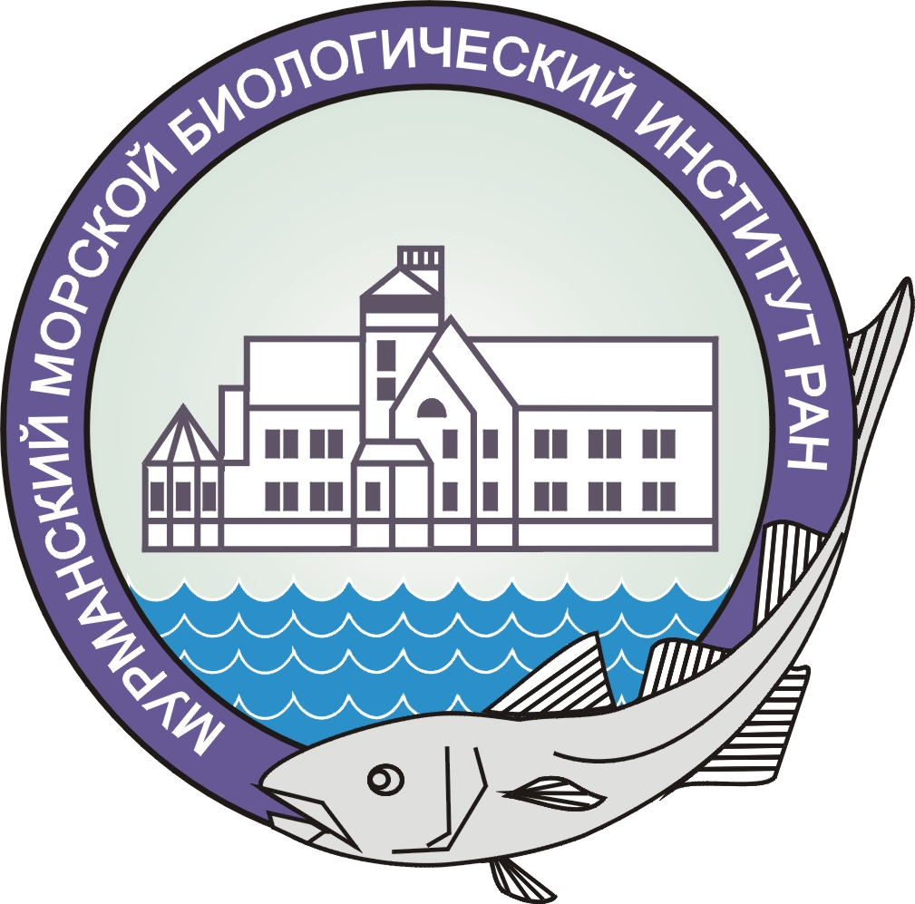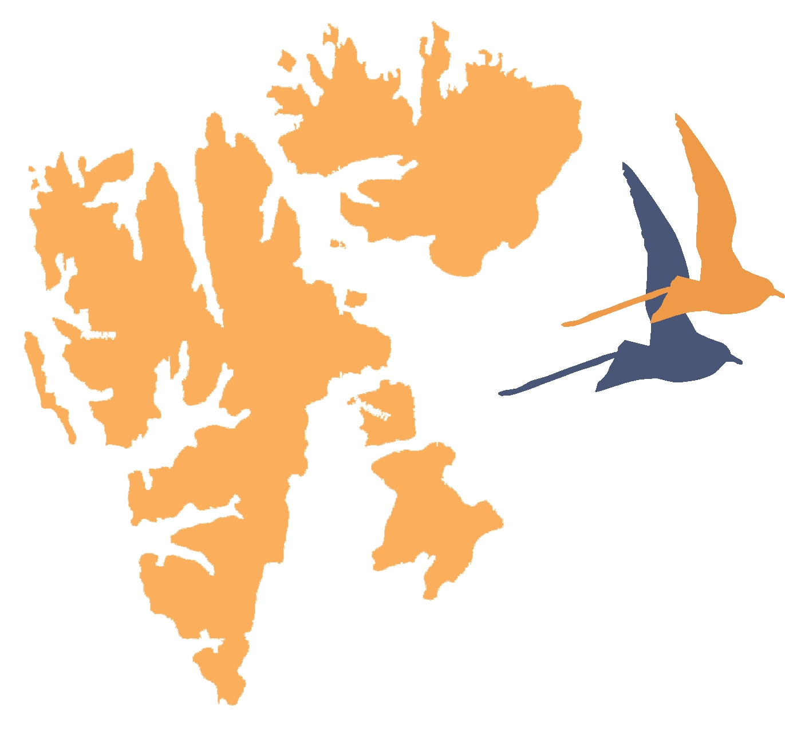
Dear colleagues!

Murmansk Marine Biological Institute KSC RAS invites you to participate in the XIII All-Russia scientific conference with international engagement «Integrated studies of Spitsbergen nature and offshore», organized in association with Federal agency of scientific organizations, Federal state unitary enterprise «Trust Arktikugol», All-Russian non-governmental organization Murmansk regional branch Russian Geographical Society and Association of polar explorers of the Murmansk region. The aim of the Conference is to consider the most important aspects of scientific researches on the Svalbard and offshore, to discuss plans and the future research activities, international collaboration etc.

Keynote topics
- Existing environmental conditions of the Arctic
- Dynamics of climatic changes
- Environmental assessment of ecosystems and ecological-resources potential
- Biodiversity and producing capacity of the Arctic ecosystem's communities
- Glacier dynamics, periglacial effects and processes
- Geosciences
- Quaternary geology and palaeogeography
- Instruments and methods for researching of the Svalbard nature
- Archeological researches

Form of presentation: plenary presentations (25 min), section presentations (15 min).
Language of reporting: Russian and English
Deadlines: submit an application – up to the 1st of April 2016; sending materials - up to the 1st of May 2016, mailing conference agenda – the 1st of October 2016; deadline for arrival and registration of participants is the 2nd of November 2016.
Formation of the presentation: proceedings of the Conference will be published by the beginning of the Conference. The paper should be within 5 pages (including 1 picture and/or 1 table). The paper is to be printed with single-spaced text and 12 pt type Times New Roman in MS Word 6.0/95/97/2000/XP/2003 (without styles and macros) or RTF. References should be given at the end of the document in alphabetical order (without numeration). References in the text should be given as follows: (2nd name, 1st name, 2005). Please submit black-and-white figures with resolution of 600 dpi for line figures and 300 dpi for half-tone figures in .jpg or .tif formats. Vector figures should be submitted in .ai, .cdr, or .eps formats.
Papers submitted after the 1st of May 2016 and not satisfying the aforementioned requirements will not be accepted by the Organizing Committee.
Organizing Committee
Matishov G.G. – chairman, academician, MMBI KSC RAS
Frolov I.E. – co-chairman, Doctor of sciences, Arctic and Antarctic Research Institute
Makarevich P.R. – vice-chairman, professor, Doctor of sciences, MMBI KSC RAS
Tarasov G.A. – vice-chairman, professor, Doctor of sciences, MMBI KSC RAS
Vinogradov A.N. – Ph.D., Kola Branch of Geophysical Survey of RAS
Veselov A.P. – Ph.D., Federal state unitary enterprise «Trust Arktikugol»
Golubeva N.I. – Ph.D., Federal agency of scientific organizations
Zhirov V.K. – RAS corresponding member, Polar-Alpine Botanical Garden-Institute KSC RAS
Kazanin G.S. – Ph.D., Joint Stock Company «Marine Arctic Geological Expedition», Association of
polar explorers of the Murmansk region
Kryukov V.D. – Ph.D., Federal State Enterprise «Polar Marine Geological Expedition»
Lebedeva N.V. – Professor, Doctor of sciences, MMBI KSC RAS
Moiseev D.V. – Ph.D., MMBI KSC RAS, All-Russian non-governmental organization Murmansk
regional branch Russian Geographical Society
Osokin N.I. – Ph.D, Institute of Geography
Starkov V.F. – Professor, Doctor of sciences, Institute of Archaeology RAS
Sirotkin A.N. – Doctor of Sciences, Federal State Enterprise «Polar Marine Geological Expedition»
Tereshchenko E.D. – Professor, Doctor of sciences, Polar Geophysical Institute KSC RAS
Shipilov E.V. – Professor, Doctor of sciences Polar Geophysical Institute KSC RAS
Alexey Marchenko – Professor, UNIS, Svalbard
Janne Soreide – Ass. Professor, UNIS, Svalbard
Piotr Glowacki – Ass. Professor, IGF PAS, Warszawa, Poland
Riko Noormets – Ass.Professor, UNIS, Svalbard
Tove Gabrielsen – Ass. Professor, UNIS, Svalbard

Secretariat
Ivakina Yu.I.: ivakina@mmbi.info
Zimina O.L.: zimina@mmbi.info

Address of the Organizing Committee: Vladimirskaya Str. 17, Murmansk, 183010, Russia
Phone: (815-2) 27-91-76; 23-00-32; 25-06-96
Contact information: Official e-mail of the Organizing Committee for acceptance of applications and materials is euro-arctic@mmbi.info.

REGISTRATION FORM
XIII All-Russia scientific conference with international engagement
«Integrated studies of Spitsbergen nature and offshore»
Murmansk,
2-4 November 2016
Surname ______________________________
Name ________________________________
Middle name ___________________________
Academic degree _______________________
Academic rank _________________________
Position _______________________________
Organization __________________________
Address _______________________________
Telephone _____________________________
Fax ___________________________________
Е-mail ________________________________
Title of report __________________________
( ) Oral report
( ) Poster

