DEAR COLLEAGUES!
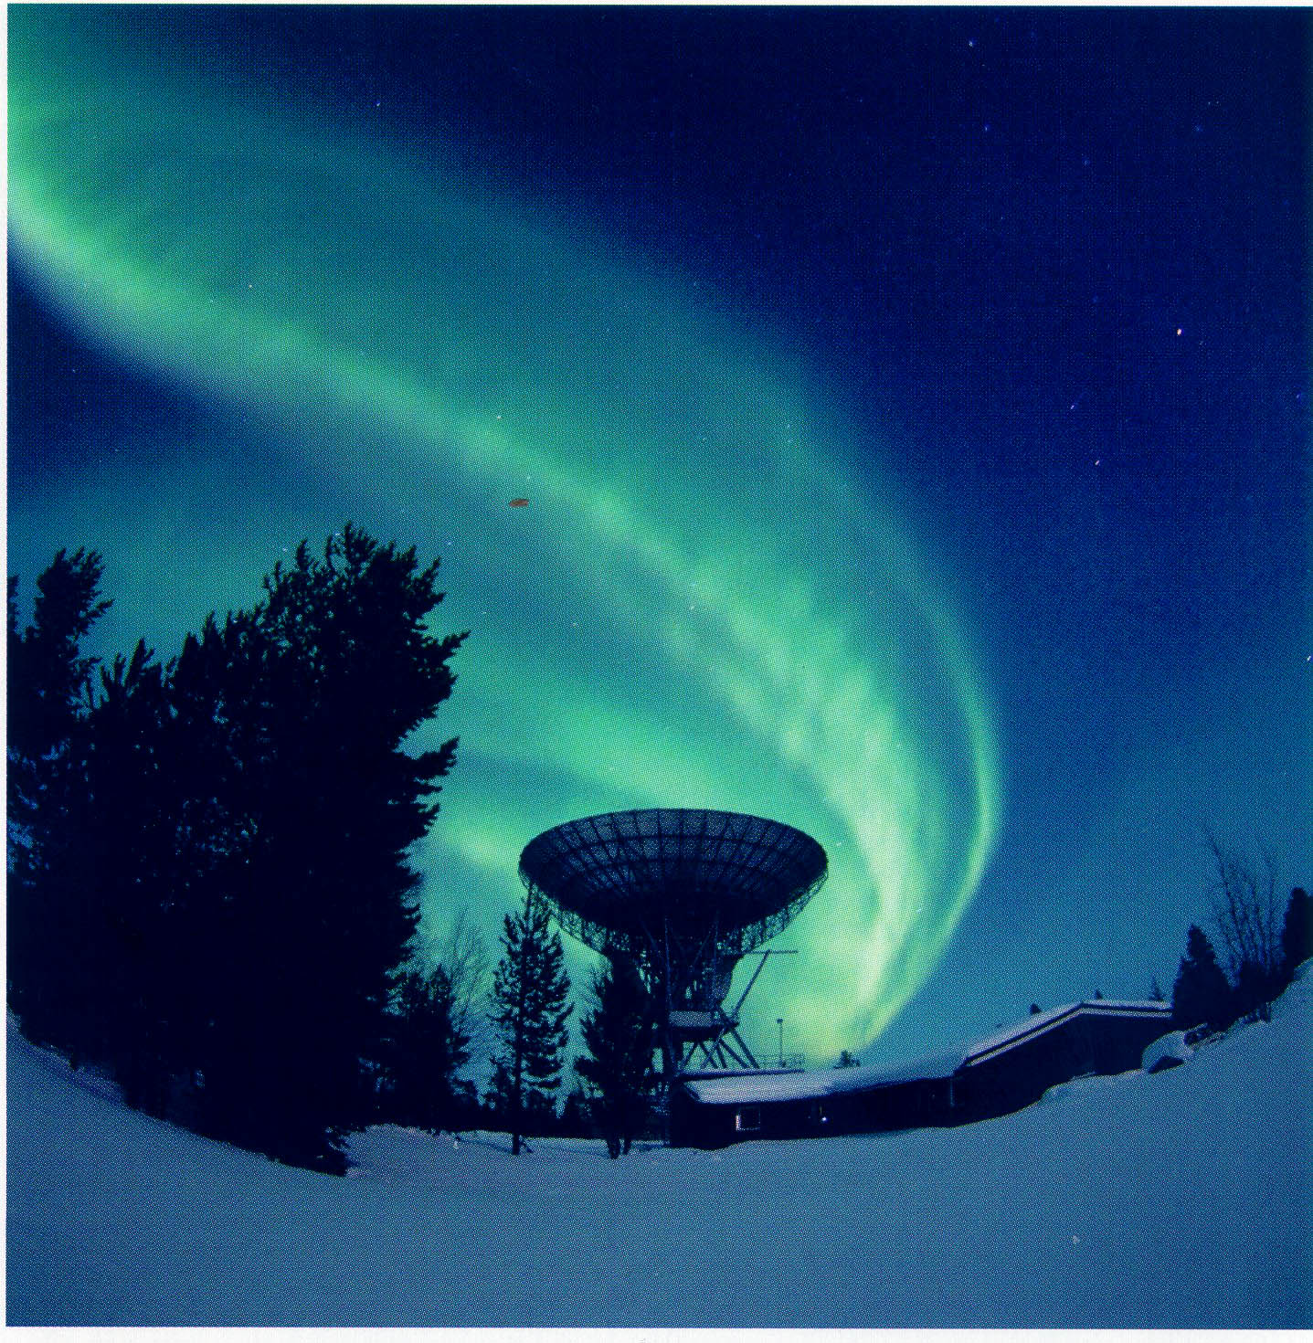
We invite you to take part in
the 15th International Scientific Conference
for Students and Post-graduates
PROBLEMS OF THE ARCTIC REGION

The conference program includes the following sessions:
BIOLOGY AND MEDICINE
CHEMISTRY AND TECHNOLOGIES
ECOLOGY OF THE NORTH
ECONOMICAL PROBLEMS OF ARCTIC DEVELOPMENT
EDUCATION IN THE ARCTIC REGION
GEOLOGY AND GEOPHYSICS OF THE ARCTIC REGION
HUMANITARIAN AND SOCIAL PROBLEMS
INFORMATION TECHNOLOGIES AND
MATHEMATICAL METHODS
MARINE BIOLOGY
PROBLEMS OF PHYSICS

The conference will be opened at 11 a.m. on Thursday, 14 May 2015,
at 17 Vladimirskaya Str., Murmansk, Russia, MMBI
http://www.mmbi.info

PHOTO FROM ESRANGE, SWEDEN

Welcome!!!

