INVITATION to the XII International scientific conference
«Integrated studies of SPITSBERGEN nature and offshore»
(6-8 November 2014, Murmansk)
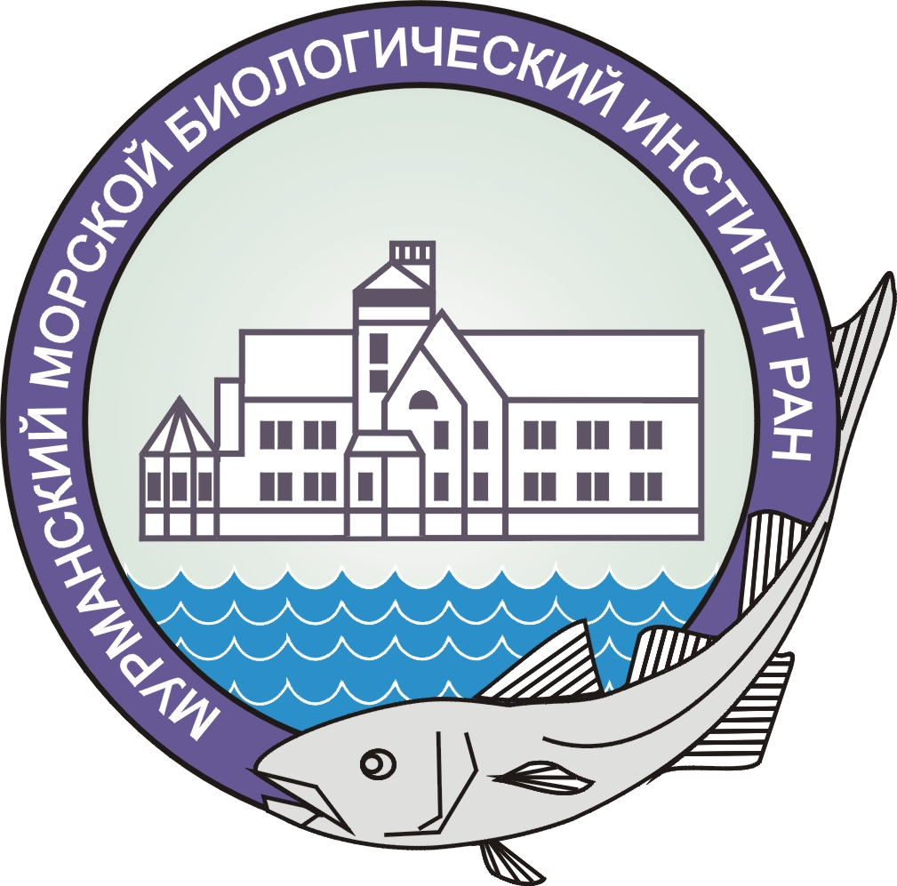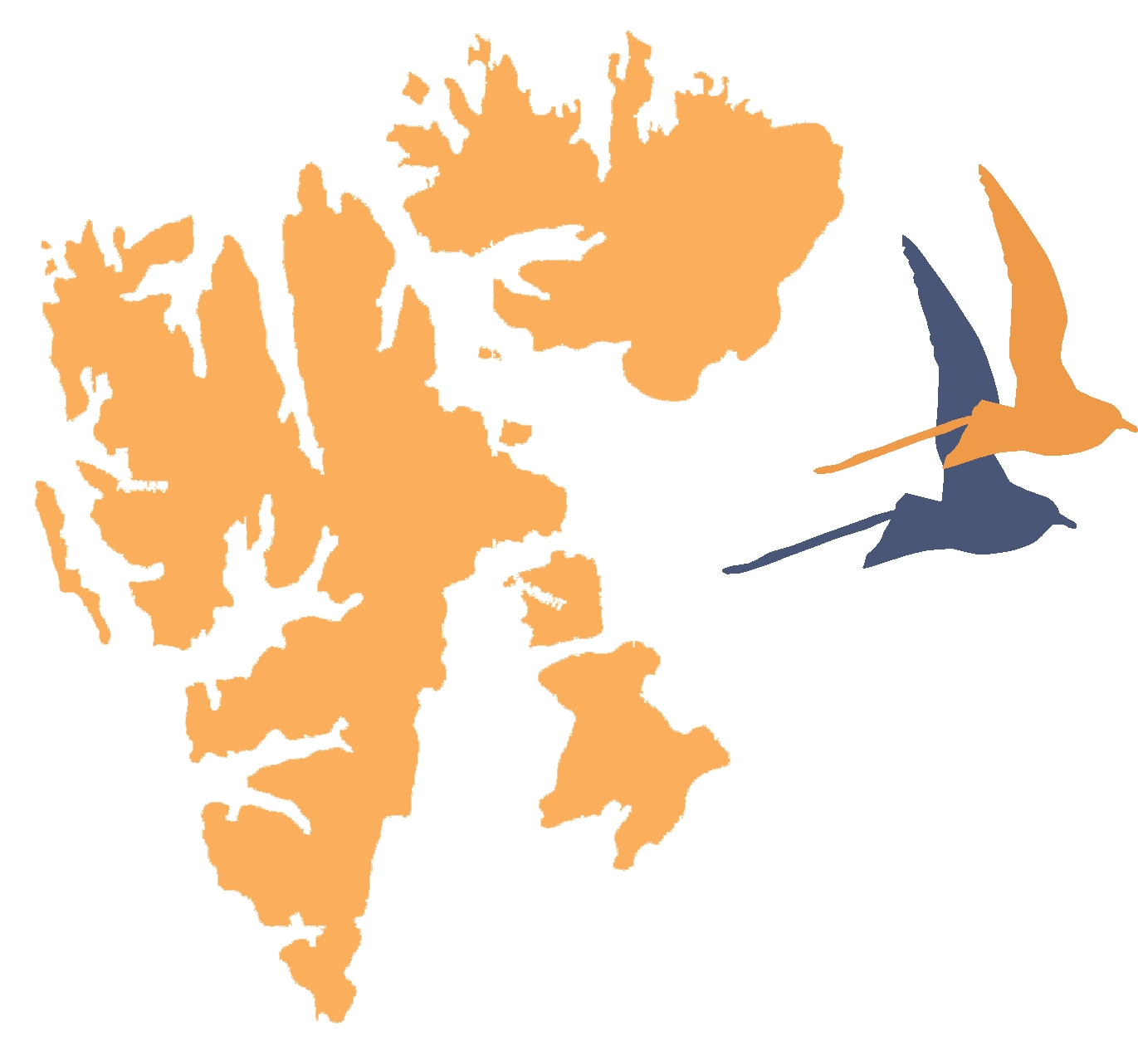
Dear colleagues!

Murmansk Marine Biological Institute, Federal agency of scientific organizations, Ministry of Economic Development of the Russian Federation, Ministry of Education and Science of the Russian Federation, Federal state unitary enterprise «Trust Arktikugol» are organizing the International scientific conference «Integrated studies of Spitsbergen nature and offshore». The meeting is dedicated to «The Year of Science Russia – EU». The aim of the Conference is to consider the most important aspects of scientific researches on the Svalbard and offshore, to discuss plans and the future research activities, international collaboration etc.

Keynote topics
- Existing environmental conditions of the Arctic
- Dynamics of the climatic changes
- Environmental assessment of ecosystems and ecological-resources potential
- Biodiversity and producing capacity of the Arctic ecosystem's communities
- Glacier dynamics, periglacial effects and processes
- Geosciences
- Quaternary geology and palaeogeography
- Instruments and methods for researching of the Svalbard nature
- Archeological researches

Form of presentation: plenary presentations (25 min), section presentations (15 min).
Language of reporting: Russian and English
Deadlines: submit an application – up to 15th of April 2014; sending the materials - up to 1st of June 2014, mailing meeting agenda – 1st of October 2014; deadline for arrival and registration to the meeting is 6th of November 2014.
Registration fee: conference participants - 500 RUB; students/postgraduate students – 200 RUB, foreign conference participants - 1200 RUB.
Bank account details: TIN 5193800144/ RRC 519001001, MMBI KSC RAS, Settlement account 405 018 109 000 020 000 01 in GRKC Bank of Russia in Murmansk region, Murmansk, BIK (sort code) 044705001, facial account 20496Ц67840 in UFC of the Murmansk region
Attention!
We are kindly ask you to indicate the details of payment and full name of author as:
00000000000000000130 «Arrangement fee of XII conference participant, your full name, Inc. VAT». Postal bank transfers are prohibited. E-payment only. Participants of the conference will pay the registration fee in rubles at the current rate of exchange.
Formation of the presentation: proceedings of the Conference will be published by the beginning of the Conference. The paper should contain 1-5 pages (including 1 picture and/or 1 table). The paper is to be printed with single-spaced text and 12 pt type Times New Roman in MS Word 6.0/95/97/2000/XP/2003 (without styles and macros) or RTF. References should be given at the end of the document in alphabetical order (without numeration). References in the text should be given as follows: (2nd name, 1st name, 2005).
Please submit black-and-white figures with resolution of 600 dpi for line figures and 300 dpi for half-tone figures in .jpg or .tif formats. Vector figures should be submitted in .ai, .cdr, or .eps formats.
Papers submitted after the 1st of June 2014 and not satisfying the aforementioned requirements will not be accepted by the Organising Committee.
Organizing Committee
Matishov G.G. – chairman, academician, MMBI KSC RAS
Frolov I.E. – co-chairman, Doctor of sciences, Arctic and Antarctic Research Institute
Makarevich P.R. – vice-chairman, professor, Doctor of sciences, MMBI KSC RAS
Tarasov G.A. – vice-chairman, professor, Doctor of sciences, MMBI KSC RAS
Vinogradov A.N. – Ph.D., KSC RAS, Kola Regional Seismological Center of the RAS Geophysical Service
Veselov A.P. – Ph.D., Federal State Enterprise «Arktikugol»
Zhirov V.K. – RAS corresponding member, Polar-Alpine Botanical Garden-Institute KSC RAS
Kazanin G.S. – Ph.D., Joint Stock Company «Marine Arctic Geological Expedition»
Kryukov V.D. – Ph.D., Federal State Enterprise «Polar Marine Geological Expedition»
Larina T.M. – Ph.D, Ministry of Education of the Murmansk region
Mokrotovarova O.I. – Murmansk Administration for Hydrometeorology and Environmental Protection
Osokin N.I. – Ph.D, Institute of Geography
Starkov V.F. – professor, Doctor of sciences, Institute of Archaeology RAS
Sirotkin A.N. – Doctor of Sciences, Federal State Enterprise «Polar Marine Geological Expedition»
Studenetsky A.S. – Federal Agency of Science and Innovations, Ministry of Education and Science of the Russian Federation
Tereshchenko E.D. – professor, Doctor of sciences, Polar Geophysical Institute KSC RAS
Shipilov E.V. – professor, Doctor of sciences Polar Geophysical Institute KSC RAS

Secretariat
Ivakina Yu.I.: ivakina@mmbi.info
Ivanenko N.Yu.: ivanenko@mmbi.info
Malavenda S.V.: malavenda@mmbi.info

Address of the Organizing Committee: Vladimirskaya Str. 17, Murmansk, 183010, Russia
Phone: (815-2) 27-91-76; 23-00-32; 25-06-96
Contact information: Official e-mail of the Organizing Committee for acceptance of applications and materials is euro-arctic@mmbi.info.

REGISTRATION FORM

XII International Scientific Conference
«Integrated studies of Spitsbergen nature and offshore»
Murmansk,
6-8 November 2014
Surname ______________________________
Name ________________________________
Middle name ___________________________
Academic degree _______________________
Academic rank _________________________
Position _______________________________
Organization __________________________
Address _______________________________
______________________________________
Telephone _____________________________
Fax ___________________________________
Е-mail ________________________________
Title of report __________________________
______________________________________

( ) Oral report
( ) Poster

